Introduction 1
Reflective - What I learnt ? 1
On the tools experience 1
Testing end-to-end 1
Figure of eight test 2

Introduction

On Wednesday 26th November 2025 I gained valuable practical experience across domestic properties in Leicestershire.

Reflective - What I learnt ?

On the tools experience

I learnt that when you have a single 2.5 mm² use short-nose pliers to bend back the copper wire in order to create more copper surface area for the terminal to grip. This improves the connection.

Testing end-to-end

We visited a few different residences on this day however, I wanted to focus on the last site visit. For a basic overview, the homeowner built an extension to enlarge the kitchen. As part of the extension there were some sockets that had to be installed in a ring final circuit.

The first test was an end to end test.

A end to end is when you test:

Brown live from cable one with the brown live from cable two;
Blue neutral from cable one with blue neutral from cable two;
Green and yellow CPC from cable one with Green and yellow CPC from cable two.

An end-to-end test for example with the brown live wires. Imagine that you stretch out the brown live wire as far as possible. With that test you want to confirm that electrons flow from one end of the brown live wire to the other end. However, in reality we have sockets and fuse connection units and other appliances that increase resistance and cause voltage drop. For an end-to-end test we expect the ohms (resistance) of the CPC to be higher than both the brown line and blue neutral wires. The reason for this is because the CPC is smaller than both the brown line and blue neutral wire. This means there is less space. A good analogy is if we have two water pipes. Pipe A and pipe B.

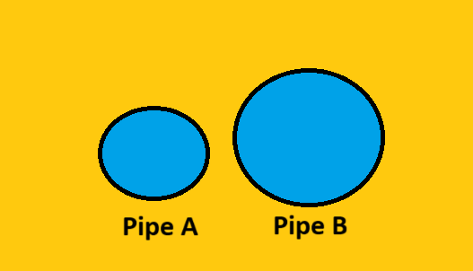

The water pressure in pipe A will be higher than pipe B. This is because in pipe A, there is less room/space for the water to flow. Electrons behave in the same manner as water particles. The resistance (measured in ohms) of a CPC wire will be higher compared to the blue neutral and brown live wire. Because, the latter two wires have a greater cross-sectional area which means a lower resistance value.

Figure of eight test

We also conducted a figure of eight tests.

In simple terms, a figure of eight test is when you test:
The brown live wire from cable one. With the cpc from cable two.
The brown live wire from cable two with the cpc from cable one.

The brown live wire from cable one with the blue neutral wire from cable two.
The brown live wire from cable two with the blue neutral wire from cable one.

Depiction of the figure of eight test

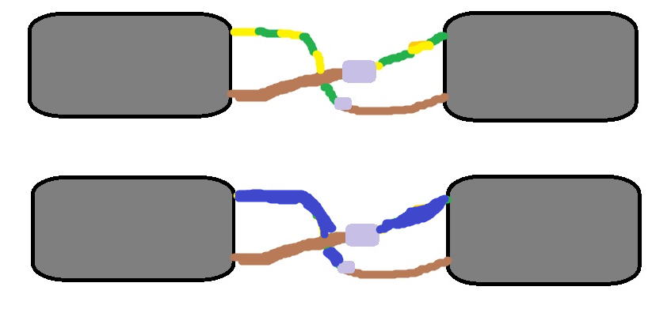

The figure of eight does not have to be performed at the fuse board and can be arranged at a socket.

Once you have organised for a figure of eight test use a tester plug and go around each and every socket on the ring circuit and note down the highest reading.

